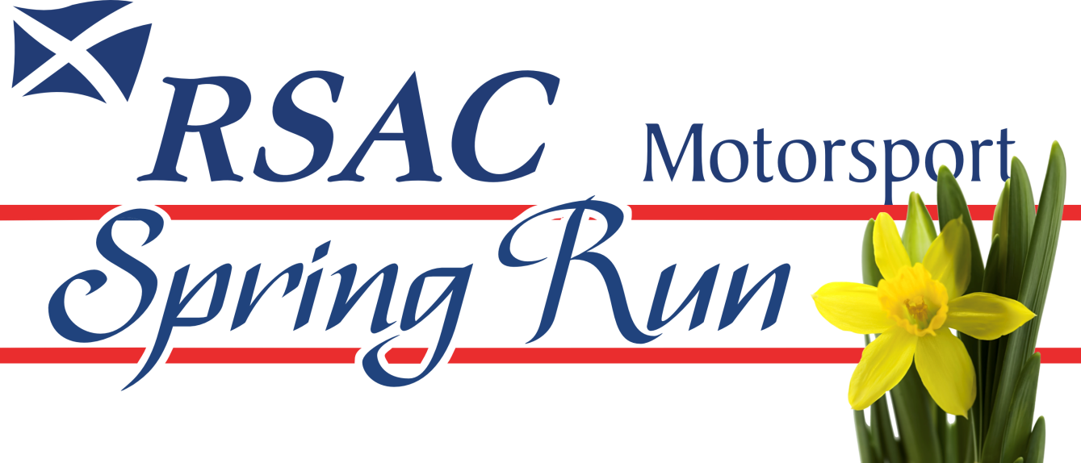
Sunday 12April 2026
ENTRY FORM
Held under the National Competition Rules of Motorsport UK (incorporating the provisions of the
International Sporting Code of the FIA) and these Supplementary Regulations.

DRIVER |  | NAVIGATOR
NAME |  | NAME
ADDRESS |  | ADDRESS
POSTCODE |  | POSTCODE
TELEPHONE |  | TELEPHONE
MOBILE |  | MOBILE
E-MAIL |  | E-MAIL
AGE (IF UNDER 18) |  | AGE (IF UNDER 18)
All entrants must sign the Declaration on Page 2. Entrants under 18 years require a Parent or Guardian to sign the Declaration on Page 2. Prospective entrants and competitors are advised that information supplied on the entry form will be held on a computer and used for the administration of the event.

DRIVER’S NEXT OF KIN |  |  |  | NAVIGATOR’S NEXT OF KIN
NAME |  |  |  | NAME
ADDRESS |  |  |  | ADDRESS
POSTCODE |  |  |  | POSTCODE
TELEPHONE |  |  |  | TELEPHONE
MOBILE |  |  |  | MOBILE
VEHICLE DETAILS
MAKE/MODEL |  |  |  | ENGINE SIZE
YEAR |  |  |  | REG. NUMBER

ROUTE CHOICE | LONG |  | SHORT | (delete as appropriate)
ENTRY FEE £20 |  | PAYMENT METHOD BANK TRANSFER / CHEQUE (delete as appropriate)
DECLARATION
I declare that I have been given the opportunity to read the NCR and, if any, the Official Documents for this event and agree to be bound by them. I declare that I am physically and mentally fit to take part in the event and I am competent to do so. I acknowledge that I understand the nature and type of the competition and the potential risk inherent with motor sport and agree to accept that risk.
I understand that motor sport can be dangerous and accidents causing death, injury, disability and property damage can and do happen. I understand that these risks may give rise to my suffering personal injury or other loss and I acknowledge and accept these risks. In consideration of the acceptance of this entry I agree that neither any one of or any combination of Motorsport UK and its associated clubs, the organisers, the track owners or other occupiers, the promoters and their respective officers, servants, representatives and agents (the “Parties”) shall have any liability for loss or damage which may be sustained or incurred by me as a result of participation in the Event including but not limited to damage to property, economic loss, consequential loss or financial loss howsoever caused. Nothing in this clause is intended to or shall be deemed to exclude or limit liability for death or personal injury. To the fullest extent permitted by law I agree to indemnify and hold harmless each of the Parties in respect of any loss or damage whatsoever and howsoever arising from my participation in this event.
I declare that to the best of my belief the driver(s) possesses (es) the standard of competence necessary for an event of the type to which this entry relates and that the vehicle entered is suitable and roadworthy for the event having regard to the course and the speeds which will be reached.I declare that the use of the vehicle hereby entered will be covered by insurance as required by the law which is valid for such part of this event as shall take place on roads as defined by the law.
If I am the Parent or Guardian of the driver, I understand that I shall have the right to be present during any procedure being carried out under the Supplementary Regulations issued for this event and the NCR. As the Parent/Guardian, I confirm that I have acquainted myself and the minor with the NCR, agree to pay any appropriate charges and fees pursuant to those Regulations (to include any appendices thereto) and hereby agree to be bound by those Regulations and submit myself without reserve to the consequences resulting from those Regulations (and any subsequent alteration thereof). Further, I agree to pay as liquidated damages any fines imposed upon me up to the maxima set out in Chapter 1, App. 2.Where the Parent is not present there must be a Guardian who must produce a written and signed authorisation from the Parent/Guardian to act as their representative.
I have read and fully understood the regulations for Control of Drugs and Alcohol as contained in the NCR Chapter 2 Art. 2, Chapter 5 App. 11 Art. 1.6, Chapter 3 Art. 17 and have also fully familiarised myself with the information on the web sites referred to (www.motorsportuk.org, www.ukad.org.uk and www.wada-ama.org) in particular the UK Anti Doping Rules which have been adopted by Motorsport UK. Further, if I am counter-signing as the Parent or Guardian of a minor then in addition to the deemed consent to the testing of that minor (UK Anti-Doping Rules in Chapter 6) I hereby confirm that I give such consent for the minor concerned to be so tested.
I hereby agree to abide by the Motorsport UK Safeguarding Policy and Guidelines and the Code of Conduct.

I confirm that I have read and agree to the terms of the Declaration.
Signature of Driver |  | Age if  under 18 |  | Date
Signature of Navigator |  | Age if  under 18 |  | Date

Consent of Parent or Guardian if Driver and/or Navigator is under 18 years of age.
Parent/Guardian of Driver |  | Parent/Guardian of Navigator
Name |  | Name
Address |  | Address
Relationship |  | Relationship
Contact No. |  | Contact No.
Signature |  | Signature



