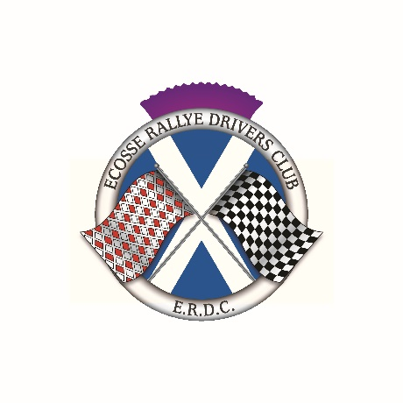
Glasgow to Edinburgh Run
25 September 2022

FOREWORD

Ecosse Rallye Drivers Club will promote the Glasgow to Edinburgh Run on Sunday 25 September 2022. The event is open to all motoring enthusiasts. The event will take the form of a one day Tour and will use some of the excellent roads in Central Scotland. Starting in Glasgow and finishing in Edinburgh, the Tour will stop off in Stirling and Perth to allow other enthusiasts to join in.

The team look forward to meeting old friends and newcomers alike.

REGULATIONS

1 Ecosse Rallye Drivers Club will promote a touring assembly on Sunday 25 September 2022 under a Certificate of Exemption issued by Motorsport UK. Permit number 127310 has been obtained.

2 The event is open to all motoring enthusiasts.

3 The event will start from the Great Western Retail Park, Glasgow G15 6RX on the morning of Sunday 25 September 2022. Entrants will be able to ‘sign on’ and join the event at Dobbies, Stirling (FK9 4UF) and Dobbies, Perth (PH1 3JJ) Times will be given in the Final Instructions. Please indicate on the entry form where you wish to start.

4 The exact location of ‘signing on’ will be given in the Final Instructions. Cars will start at one-minute intervals.

All vehicles must be road legal and have the following, where required by law.
A valid MOT Certificate
Vehicle Excise Duty paid
A minimum of Third Party Insurance for all persons who will drive the participating vehicles must be applicable for the duration of the event.

5 The route will consist of around 146 miles on public A and B Class roads which will be on sealed surfaces. Details of the route will be emailed prior to the event in the form of a tulip roadbook to enable entrants to print the roadbook and plot it onto a road atlas.

6 The entry list opens on publication of these Regulations and Entry Form and closes on Sunday 18 September 2022. Refunds for withdrawn entries will be at the discretion of the organisers.

7 The entry fee for the event is £10 per crew which will include a rally plate, numbers, and a tulip roadbook sent out by email for you to print.
All entries must be made on the entry form and emailed to Craig McGibbon the Secretary of the Event. The fee should be transferred to the ERDC bank account. ERDC bank account details are as follows:

Account Name: Ecosse Rallye Drivers Club
Bank: Santander
Sort Code: 09 01 29
Account number: 38813548

Submit Entries to Craig McGibbon
cnh.mcgibbon@gmail.com

7 Officials of the Event

Secretary of the Meeting Craig McGibbon

8 The Organisers will not be responsible for damage to, or loss of, any car, its parts or accessories, or for any damage caused by any entrant or car, and any entrant by entering and driving, and a passenger by taking part, shall thereby waive any right of action at law against the organisers for any damage sustained by him (her or them) in consequence of any act or omission on any part of the organisers, or of the officials, representatives or agents with respect to these regulations or to the run or to any matter arising therefrom.

