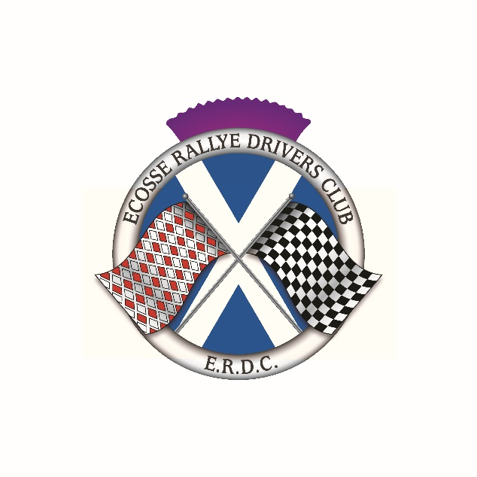
COL DE RUISG 15 January 2022

ENTRY FORM

Driver |  |  |  | Navigator
Name |  |  |  | Name
Address |  |  |  | Address
Postcode |  |  |  | Postcode
Telephone |  |  |  | Telephone
Mobile |  |  |  | Mobile
E-mail |  |  |  | E-mail
Age if under 18 |  |  |  | Age if under18
Driver’s next of kin |  |  | Navigator’s next of kin
Name |  |  | Name
Address |  |  | Address
Telephone/Mobile |  |  | Telephone/Mobile
Vehicle details
Make/model |  |  |  |  | Year |  | Reg No

Entry Fee

The entry fee for the run is £25. Completed and signed Entry Forms, should be emailed to the Secretary of the event: June Anderson, june.a.anderson@outlook.com
The entry fee should be made by bank transfer to the club bank account.
Account name: Ecosse Rallye Drivers Club;
Santander Bank; Sort Code 09 01 29; Account number 38813548
If you are unable to make payment by bank transfer please contact June to make alternative arrangements. 07484 241 695 or 01382 731755
Please note that this event will be Covid compliant, will follow all National guidance and laws in place at the time and Motorsport UK requirements. All correspondence will be by email so please ensure that your email address is legible.

Declaration
I declare that: 1) I have been given the opportunity to read the General Regulations of Motorsport UK (‘General Regulations’) and, if any, the Supplementary Regulations for this Event as well as Motorsport UK COVID-19 Guidance for Events and agree to be bound by them. I declare that I am physically and mentally fit to take part in the Event and I am competent to do so. I acknowledge the potential risks inherent with motor sport and accept that these risks may give rise to my suffering personal injury or other loss. 1(a)) I am not, neither is any person connected with my entry nominated to attend the event currently experiencing any symptoms of COVID-19 and have not done so for 10 days. I have not knowingly been in contact with anyone showing symptoms within the last 10 days, except as a healthcare professional. If after submitting this form I, or any person connected with my entry knowingly come into contact (except as a healthcare professional) with someone with COVID-19 or if I, or any person connected with my entry start to exhibit any of the signs indicating that they may be infected I will immediately withdraw from the Event together with all persons connected with my entry, notify Motorsport UK and ensure that my close contacts also do not attend. Should I, or any person connected with my entry become ill at or start to exhibit COVID-19 symptoms at the Event I shall withdraw safely and notify the Secretary of the Meeting by telephone / SMS accordingly including identification of those others who I have come into contact with at the Event. In addition, I confirm that the symptomatic person will as soon as practicable contact the NHS for the purposes of test and trace. If I have knowingly contracted COVID-19 I declare that I have been symptom free for at least 10 days and am physically fit to compete with no new medical problems that may affect my ability to safely operate a motor vehicle in competition. 1(b)) I agree to abide by all Government and Motorsport UK requirements imposed in respect of COVID-19. I understand that Motorsport UK Guidance on COVID-19 in relation to Events has Regulatory status and to the extent applicable shall supersede the General Regulations by virtue of GR A.2.4. Breach of this obligation may lead to being disqualified from the Event (C.2.5). 2) To the best of my belief the driver(s) possess(es) the standard of competence necessary for the Event to which this entry relates and that the vehicle entered conforms to the Regulations of the Event. Where applicable the use of the vehicle hereby entered will be covered by insurance as required by law. 3) I agree that should I at the time of this Event be suffering from any disability whether permanent or temporary which is likely to affect prejudicially my normal control of the vehicle, I may not take part unless I have declared such disability to Motorsport UK which has, following such declaration, issued a licence which permits me to do so. I undertake that at the time of the Event to which this entry relates I shall have passed or am exempt from an ASN specified medical examination within the specified period. (H10.1.6) 4) If I am the Parent/Guardian/Guarantor of the driver I have countersigned the competitor licence application and understand that I shall have the right to be present during any procedure being carried out under the Event Supplementary Regulations and the General Regulations and that I have acquainted myself and the minor with them, agree to pay any appropriate charges and fees pursuant to those Regulations and agree to be bound by and submit myself without reserve to the consequences resulting from them (and any alteration thereof). Further, I agree to pay as liquidated damages any fines imposed upon me up to the maxima set out in Part 3, Appendix 1. Note: Where the Parent/Guardian/Guarantor will not be present the Parent/Guardian/Guarantor must advise the organisers in advance, in writing, authorising their appointed representative to so act. Page 2 of 3 5) I hereby agree to abide by all applicable Motorsport UK Policies and Guidelines including but not exclusively Safeguarding and Anti Alcohol and Drugs policies and the National Sporting Code of Conduct. 6) I have read and shall respect the regulations for Control of Drugs and Alcohol as contained in the General Regulations C1.1.7, D35.1, G15.1.4, H38 and have also fully familiarised myself with the information on the web sites referred to (www.motorsportuk.org, www.ukad.org.uk and www.wada-ama.org) in particular the UK AntiDoping Rules which have been adopted by Motorsport UK. Further, if I am counter-signing as the parent or Guardian of a minor then in addition to the deemed consent to the testing of that minor (UK Anti-Doping Rule 5.7.2) I hereby confirm that I give such consent for the minor concerned to be so tested. 7) I understand and agree that my personal data, and that of the persons connected to my entry are being processed solely for the purposes of running this Event and may be used for the purposes of COVID-19 infection tracing, and will be handled by the organisers in accordance with Motorsport UK data protection policy: www.motorsportuk.org/data-protection. 8) I confirm I will bring all required documentation, licences etc., to the Event as usual and I understand that spot checks will be made with regard to documentation and technical checks. Indemnity: In consideration of the acceptance of this entry I agree that neither any one of or any combination of Motorsport UK and its associated clubs, the organisers, the track owners or other occupiers, the promoters and their respective officers, servants, representatives and agents (the “Parties”) shall have any liability for loss or damage which may be sustained or incurred by me as a result of participation in the Event including but not limited to damage to property, economic loss, consequential loss or financial loss howsoever caused. Nothing in this clause is intended to or shall be deemed to exclude or limit liability for death or personal injury. To the fullest extent permitted by law I agree to indemnify and hold harmless each of the Parties in respect of any loss or damage whatsoever and howsoever arising from my participation in this Event. Pre-Event Scrutineering declaration: By submitting this Declaration and in consideration of being permitted to take part in the above Event I undertake and confirm with the Organisers and Motorsport UK that: General 1) I have read and understand the requirements of General Regulations (H)31.1.5 – 31.1.8. As Entrant I shall comply with all Regulations that apply to my Entry including General, Supplementary and Championship Regulations as well as any other Final Instructions. General Technical 2) The vehicle complies with all relevant General Vehicle Technical Regulations [(J)5] and relevant Supplementary and/or Championship Regulations 3) The vehicle complies with the relevant Maximum Noise Limit [(J) Appendix 1: Chart 5.18] Discipline specific Technical 4) The Vehicle complies with the specific Technical Regulations for the discipline [Autotests – (M), Autocross and Rallycross – (N), Cross-Country – (P), Circuit Racing – (Q), Rallying – (R), Sprints, Hill Climbs and Drag Racing – (S), Trials – (T), Karting – (U)]. Safety 5) The vehicle complies with the relevant General Vehicle Safety Regulations [Section (K)]. And in particular: 6) Where a Roll Over Protection System is required, it complies with the relevant parts of (K)1 7) Where FIA homologated harnesses are required, it has/they have not passed the expiration date on the label, or any extension afforded by Motorsport UK Regulations [J2.1.7] 8) Where FIA homologated seats are required, it has/they have not passed the expiration date on the label, or any extension afforded by Motorsport UK Regulations [R48.10.6]. 9) Driver/Co-Driver Personal Protective Equipment (PPE) complies with the General Regulations where applicable. Note: Helmets and FHR devices which do not bear a Motorsport UK (or MSA) Approval sticker must be presented to the Scrutineers who will visually inspect the equipment and issue a sticker in accordance with the Motorsport UK COVID-19 helmet stickering procedure.

I confirm that I have read and agree to the terms of the Declaration
Signature of Driver |  |  | Age if  under 18 |  |  | Date
Signature of Navigator |  |  | Age if  under 18 |  |  | Date
Consent of Parent or Guardian if Driver and/or Navigator is under 18 years of age.
Parent/Guardian of Driver |  |  | Parent/Guardian of Navigator
Name |  |  | Name
Address |  |  | Address
Relationship |  |  | Relationship
Contact No. |  |  | Contact No.
Signature |  |  | Signature

Data Protection Act: Prospective entrants and competitors are advised that information supplied on the entry form will be held on a computer and used for the administration of the event.

