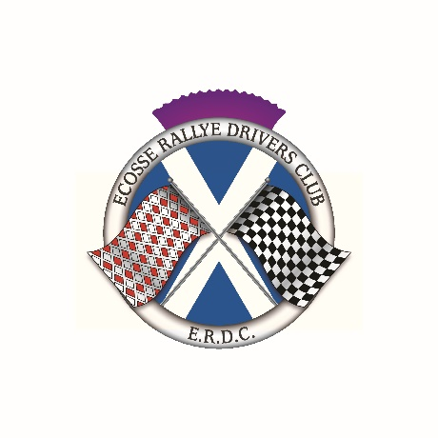
COL de RUISG
15 JANUARY 2022

FOREWORD

Ecosse Rallye Drivers Club will promote the Col de Ruisg on 15 January 2022. The event is open to all motorsport enthusiasts and is designed to allow crews to practice navigational skills and will provide an opportunity for the driver and navigator to work together as a team. The event will be particularly useful to those who have entered the Rallye Monte Carlo Historique or Classique. The event will take the form of an evening Winter Tour and will use some of the excellent roads through Argyll and Perthshire. The team look forward to meeting old friends and newcomers alike.

REGULATIONS

1 Ecosse Rallye Drivers Club will promote a touring assembly on Saturday 15 January 2022 under a Certificate of Exemption issued by Motorsport UK. Permit number 334596 has been issued.

2 The event is open to all classic car enthusiasts.

3 The events will start from the car park adjacent to the swimming baths at West Clyde Street, Helensburgh and finish in Callander. Details of the start and finish venues will be given in the Final Instructions. The first car will leave at 1900 on Saturday 15 January 2022.

4 Signing On will take place electronically on the new Motorsport UK signing on declaration which will be emailed by the secretary of the event to all participants and must be returned via email to her. june.a.anderson@outlook.com Individual start times will be issued with the Final Instructions. Cars will start at one-minute intervals.

All vehicles must be road legal and have the following, where required by law.
A valid MOT Certificate
Vehicle Excise Duty paid
A minimum of Third Party Insurance for all persons who will drive the participating vehicles must be applicable for the duration of the event.

5 The route will consist of around 55 miles on public A and B Class and unclassified roads which will all be on sealed surfaces. Details of the route will be emailed prior to the event in the form of a tulip roadbook.

6 The entry list opens on publication of these regulations and entry form, closing on Sunday 9 January 2022. Refunds for withdrawn entries will be at the discretion of the organisers.

7 The entry fee for the event is £25, which will include a rally plate, numbers, and other necessary documents. Light refreshments will be served after the event. All entries must be made on the entry form and should be emailed to the Secretary of the Meeting. The fee should be transferred to the ERDC bank account. ERDC bank details are as follows:
Account Name: Ecosse Rallye Drivers Club
Bank: Santander
Sort Code: 09 01 29
Account number: 38813548

Submit Entries to June Anderson
email: june.a.anderson@outlook.com

7 Officials of the Event

Secretary of the Meeting June Anderson

8 The Organisers will not be responsible for damage to, or loss of, any car, its parts or accessories, or for any damage caused by any entrant or car, and any entrant by entering and driving, and a passenger by taking part, shall thereby waive any right of action at law against the organisers for any damage sustained by him (her or them) in consequence of any act or omission on any part of the organisers, or of the officials, representatives or agents with respect to these regulations or to the run or to any matter arising therefrom.

